IT24100191 – Lab 08

01)

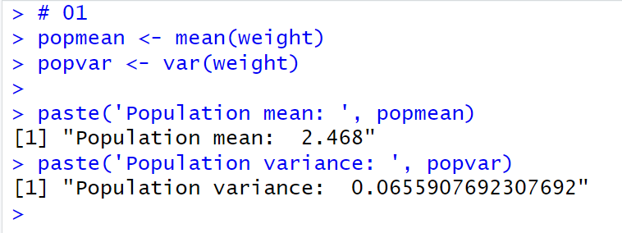

02)

03)

